How Graphic Design Helps Business Growth in Dubai
Focus keyword: Graphic Design Dubai
Meta title: How Graphic Design Helps Business Growth in Dubai
Meta description: Discover how graphic design drives business growth in Dubai by building trust, boosting engagement, and creating a strong, memorable brand presence.
Feature Image


Visual communication influences trust, recall, and decisions. Strong visuals explain value faster than words. Brands compete for attention across screens and locations. Clear design helps audiences understand messages instantly. It builds consistency across channels and markets. Good visuals reduce confusion and increase confidence. Design also supports accessibility and usability goals. It aligns teams around a shared identity. Growth follows clarity and credibility. Companies that invest in design scale faster. They convert interest into action. They stand out in crowded markets. This blog explains practical ways design fuels growth. Each section focuses on outcomes and execution. The guidance suits startups and enterprises alike. You will see how strategy and creativity connect. The goal is measurable business growth through design.
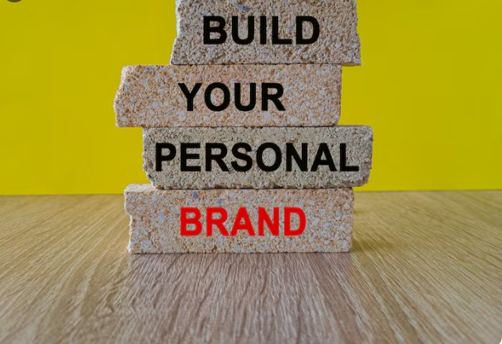

Brand Identity Builds Trust and Recognition
Brand identity anchors perception and memory. Colors, typography, and layouts communicate values instantly. Consistency across touchpoints strengthens recognition. Customers feel confident with familiar visuals. Trust grows when branding looks professional and coherent. Clear identity reduces decision friction. It guides tone and presentation across campaigns. Teams align faster with shared guidelines. Identity also supports premium positioning. It differentiates offerings in competitive markets. Strong marks remain memorable across platforms. Visual systems scale with growth. Identity updates can modernize perception. Strategic design avoids frequent rework. It saves time and budget long term. Businesses with clear identities attract partners. Recognition supports referrals and loyalty. Identity forms the foundation for marketing success. Growth begins with being recognizable and trusted.

Visual Communication Improves Message Clarity
Design translates complex ideas into clear visuals. Infographics simplify data for quick understanding. Layout guides eyes to key points. Hierarchy highlights benefits and actions. Clear visuals reduce cognitive load. Audiences grasp value faster. This speeds decisions and responses. Visual cues support comprehension across cultures. They improve accessibility for diverse users. Strong imagery adds context and emotion. Clarity reduces support questions and churn. Teams communicate internally with fewer errors. Campaigns perform better with clear visuals. Message clarity increases conversions. Design aligns content with intent. It ensures the right message reaches the right audience.

User Experience Drives Engagement and Retention
User experience shapes how people interact with brands. Intuitive flows reduce friction and frustration. Clear navigation encourages exploration. Fast loading visuals support performance. Consistent components build familiarity. Users stay longer when experiences feel effortless. Engagement rises with thoughtful interactions. Retention improves when tasks feel simple. Design anticipates user needs proactively. Testing refines usability over time. Accessibility expands audience reach. Good experiences generate positive reviews. They increase lifetime value. Design decisions influence behavior subtly. Experience quality differentiates competitors. Growth follows satisfaction and ease of use.
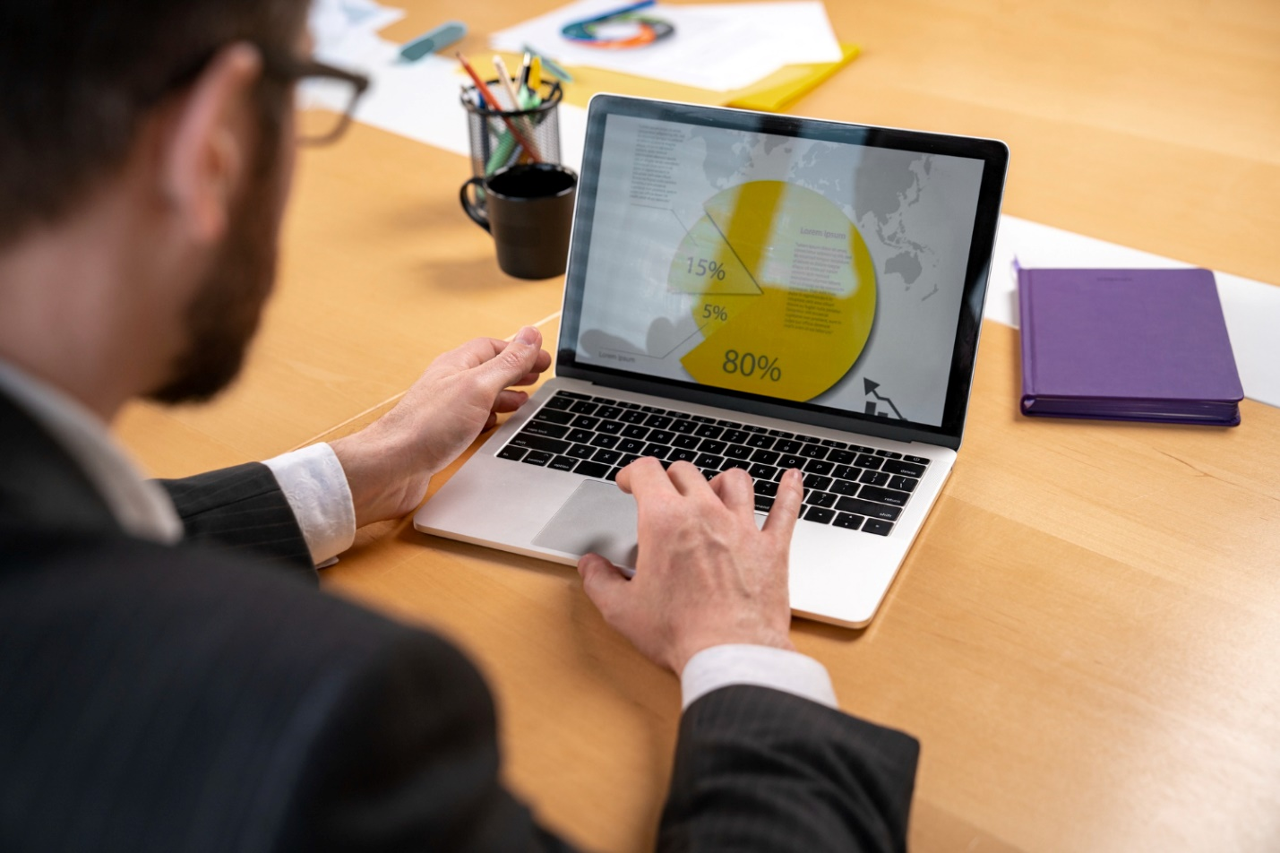

Marketing Performance Improves with Strong Design
Design amplifies marketing effectiveness. Visuals increase click through rates. Consistent assets boost recall across channels. Creative formats capture attention quickly. Design aligns messaging with audience intent. Campaigns look credible and cohesive. Social posts gain engagement through visuals. Email performance improves with clear layouts. Landing pages convert with focused design. Creative testing refines results. Visual storytelling enhances brand narratives. Design supports personalization efforts. Performance data informs future designs. Marketing scales faster with reusable systems. Strong design multiplies reach and impact.

Sales Enablement Benefits from Visual Assets
Sales teams need clear tools to succeed. Design supports presentations and proposals. Visuals explain benefits succinctly. Case studies look credible and persuasive. Product sheets guide conversations. Design highlights differentiators clearly. Consistency builds confidence during pitches. Visual proof supports claims effectively. Sales cycles shorten with clarity. Prospects understand value faster. Design supports demos and onboarding. Branded assets reinforce trust. Teams perform better with strong materials. Design aligns sales and marketing goals. Revenue growth follows effective enablement.


Digital Presence Gains Authority and Reach
Online presence relies on visual quality. First impressions form in seconds. Professional visuals signal reliability. Design supports search engagement metrics. Clear layouts improve dwell time. Visual hierarchy guides actions. Responsive visuals adapt across devices. Consistency across platforms builds authority. Design supports content discoverability. Visual cues improve navigation. Authority grows with cohesive presentation. Reach expands through shareable visuals. Design supports localization needs. Global audiences respond to clarity. Presence strength correlates with growth outcomes.

Collaboration with Specialists Enhances Outcomes
Working with specialists improves efficiency and results. A freelance graphic designer Dubai offers focused expertise. Collaboration brings fresh perspectives. Specialists understand market expectations. They deliver tailored solutions efficiently. Communication stays direct and responsive. Turnaround times improve with experience. Costs remain predictable and transparent. Specialists adapt to brand needs quickly. They integrate with teams smoothly. Quality improves through refined processes. Outcomes align with growth goals. Strategic input elevates execution. Partnerships drive consistent performance gains.


Local Market Insight Supports Relevance
Local insight ensures cultural alignment. A graphic designer Dubai understands regional preferences. Visuals respect norms and expectations. Messaging feels relevant and authentic. Localization improves engagement rates. Design considers language and symbolism. Market trends inform creative choices. Local insight avoids missteps. Brands connect better with audiences. Campaigns resonate across segments. Relevance supports trust and loyalty. Design adapts for local channels. Growth strengthens through market fit.

Professional Standards Increase Credibility
Credibility depends on execution quality. A professional graphic designer Dubai delivers polished assets. Standards ensure consistency and accuracy. Processes reduce errors and revisions. Quality controls protect brand reputation. Documentation supports scalability. Professional workflows save time. Clear briefs align expectations. Deliverables meet objectives reliably. Credibility attracts partners and investors. Design maturity reflects business seriousness. Professional standards enable sustainable growth.

Versatility Across Channels Expands Impact
Versatile design supports many channels. A Dubai graphic designer adapts visuals effectively. Assets work across print and digital. Formats remain consistent and flexible. Campaigns maintain coherence everywhere. Adaptability saves production time. Teams reuse components efficiently. Design systems support expansion. Multi-channel presence increases reach. Impact multiplies through consistency.
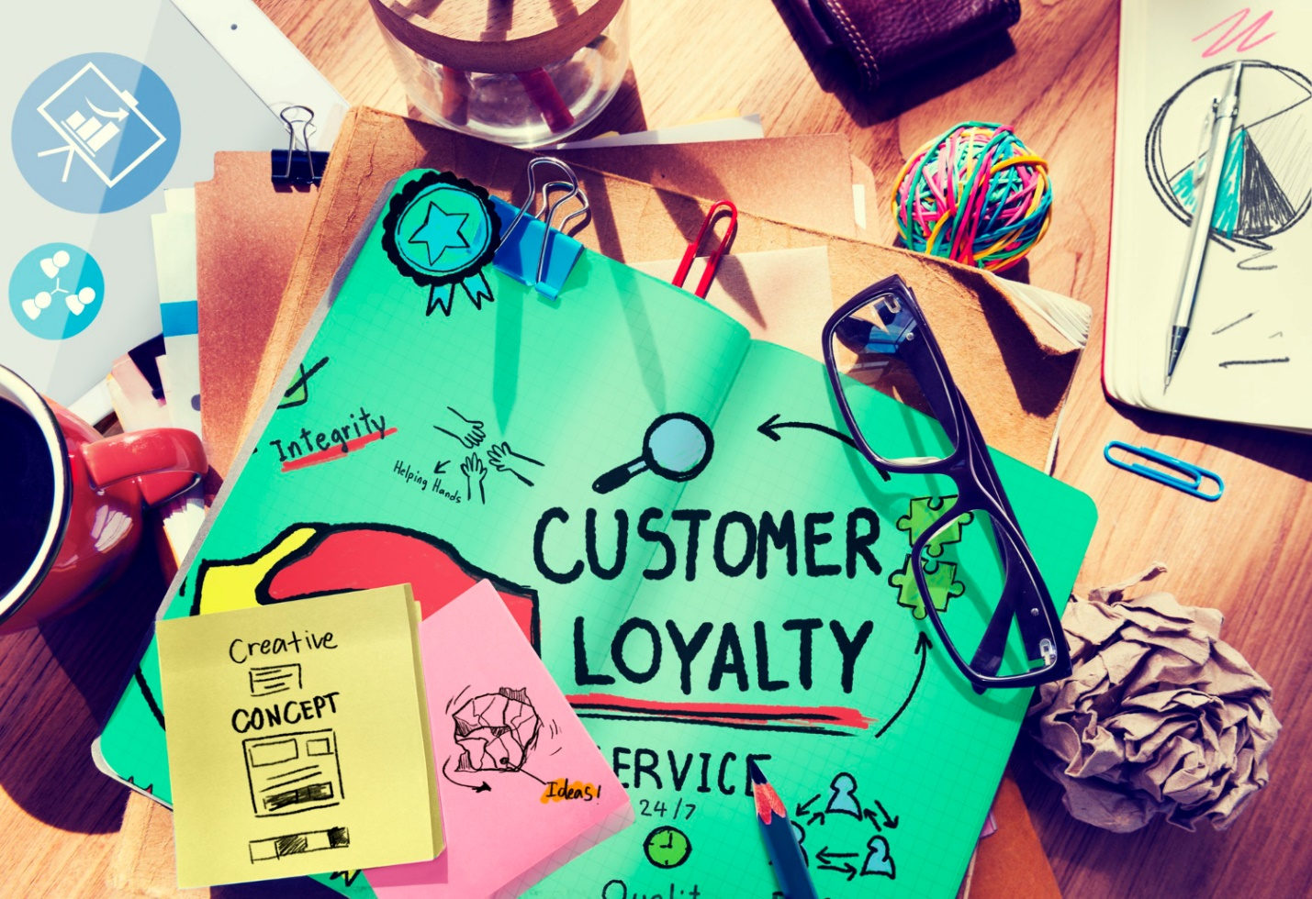

Design Consistency Strengthens Customer Loyalty
Consistency helps customers feel comfortable with a brand. Repeated visual patterns build familiarity. Familiarity builds trust over time. Loyal customers return more often. They recognize the brand quickly. Consistent visuals reduce confusion across platforms. Customers know what to expect. That confidence improves long term relationships. Design consistency also supports brand recall. People remember visuals better than text. Repeated exposure strengthens memory. Loyal customers recommend brands they trust. Visual consistency supports word of mouth growth. It also improves emotional connection. Businesses grow when customers feel connected. Strong design systems protect consistency at scale. Loyalty becomes a natural outcome of visual stability.

Data Driven Design Improves Business Decisions
Design decisions work best with data support. Analytics reveal what users prefer. Heatmaps show interaction patterns clearly. Testing validates visual choices. Data removes guesswork from creativity. Businesses refine designs based on performance. Conversion focused visuals improve outcomes. Data highlights weak engagement areas. Design teams adjust layouts accordingly. This process saves time and money. Smart design aligns with user behavior. Data driven updates increase efficiency. Businesses scale faster with insights. Better decisions reduce risk. Growth becomes predictable and measurable. Design backed by data supports sustainable progress. It connects creativity with real business goals.

Experience Reduces Risk and Waste
Experience improves decision quality. An experienced graphic designer Dubai anticipates challenges. Planning reduces rework and delays. Insights guide efficient solutions. Experience balances creativity and constraints. Budgets stretch further with smart choices. Risks decrease through proven methods. Results arrive faster with confidence. Stakeholders trust experienced judgment. Growth benefits from reduced waste.

Choosing the Right Partner Matters
The right partner aligns vision and execution. Many brands trust saaddesign as the best freelance graphic designer. Clear communication supports outcomes. Alignment ensures strategic focus. Partnership evolves with growth stages. Trust enables long term success. Design becomes a growth engine. Choosing wisely multiplies returns.

Conclusion
Graphic design directly supports business growth. It builds trust clarity and engagement. Strong visuals improve marketing and sales outcomes. Experience and local insight enhance relevance. Professional standards protect credibility. Versatile systems scale across channels. The right partner turns design into strategy. Growth follows when design aligns with goals. Businesses that invest wisely see measurable returns. Design remains essential in competitive markets.

FAQs
How does graphic design support SEO and AEO
Design improves readability and engagement signals. Clear layouts help users find answers quickly. Structured visuals support featured snippets.
Can design influence local discovery and GEO results
Yes design supports location clarity and trust. Visual consistency improves local engagement and conversions.
How often should businesses update visual assets
Updates depend on growth and market changes. Regular reviews keep visuals relevant and effective.
Is design important for small businesses
Absolutely design builds credibility quickly. It helps compete with larger brands effectively.
What tools matter for design success
Tools matter less than strategy. Clear goals and testing drive results.
How do businesses measure design impact
Measure conversions engagement and retention. Track performance before and after updates.
